# Address Change

Whether you’re moving just down the street, or across state lines, please make sure to update your address in Paylocity. If you are in fact moving states, remember to change your tax forms. Below are two how-to workflows:

1- From Paylocity - a very detailed article to guide you thru making Tax Changes: [PCTY-60897](https://access.paylocity.com/SAML/InitiateSso?sp=peak&pid=308600000001009/content/PCTY-60897)  
2- A less detailed set of screenshots from Amivero’s perspective below:

Log in to your Paylocity Account and update your profile address:

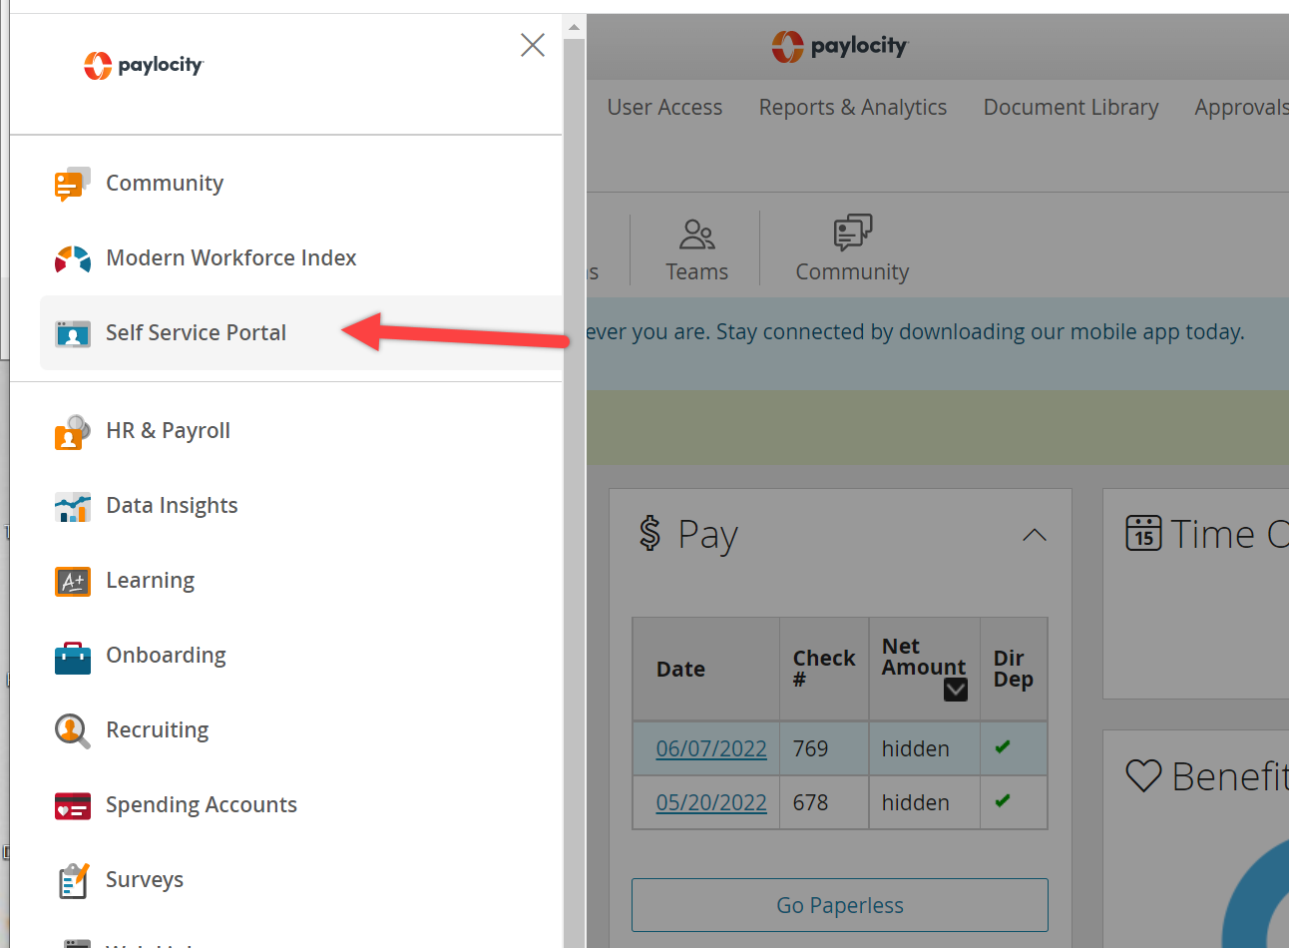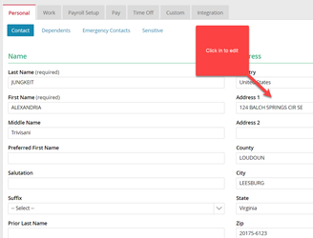

REMEMBER TO HIT THE SAVE BUTTON ONT THE BOTTOM LEFT

If you changed states, you’ll need to update the tax forms area to start paying taxes in your new state.

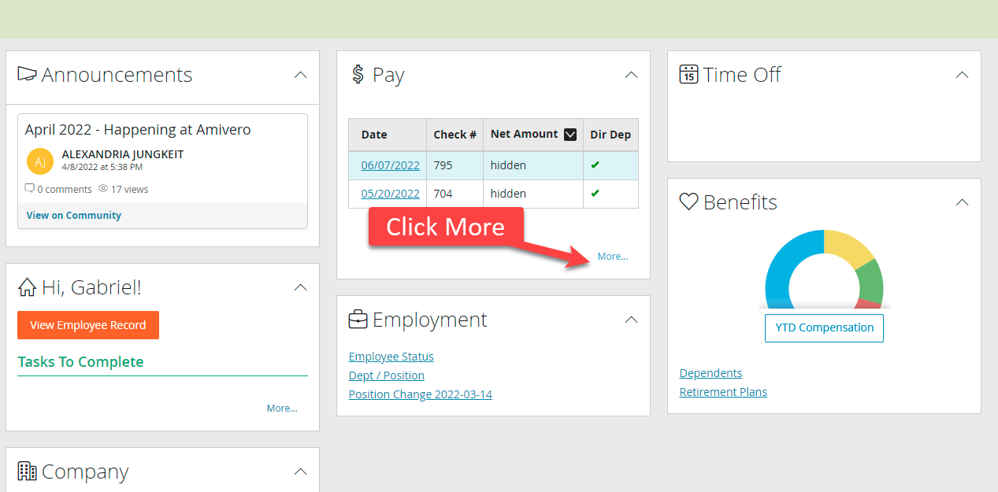

Then from the expanded section, click on “Edit Tax Setup”

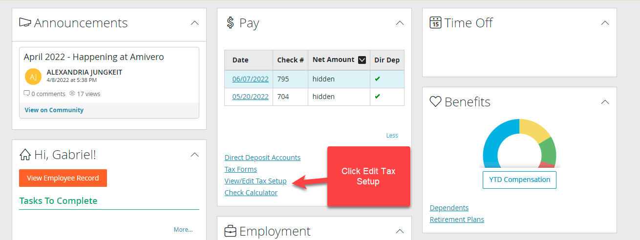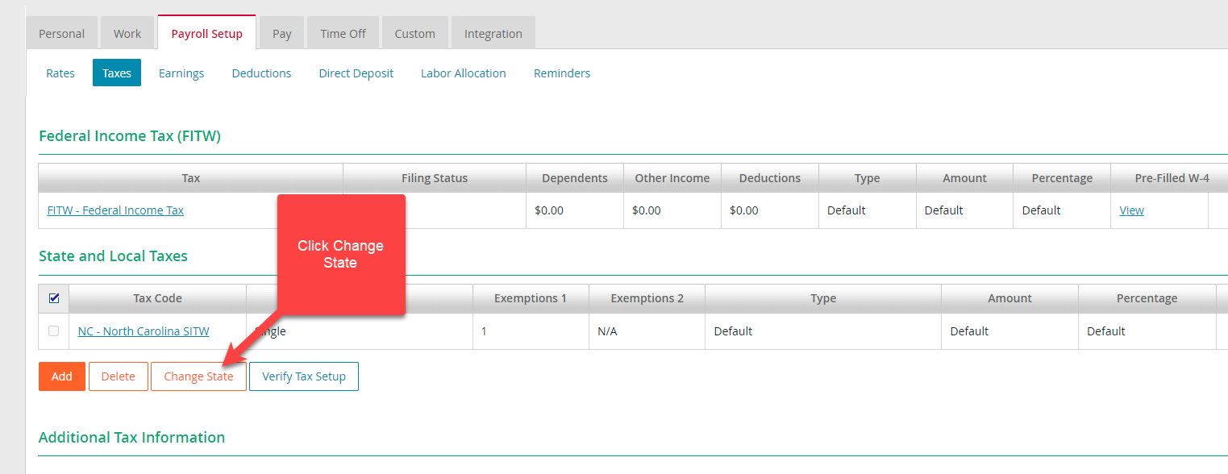

From all State Tax dropdown menus, find and select your new state:

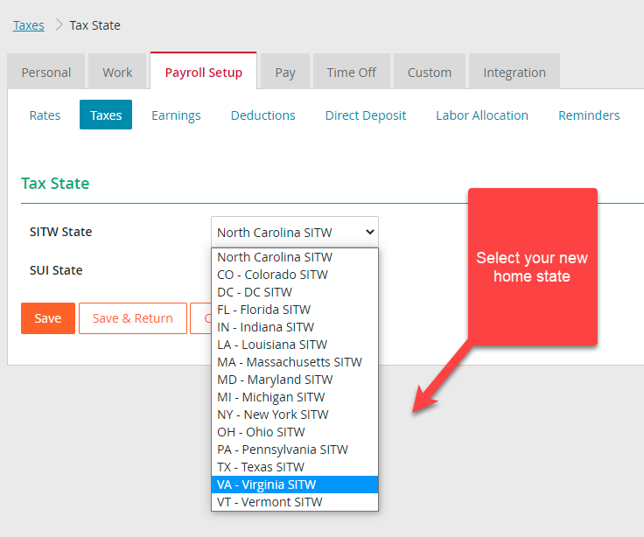

Click Save, and then fill out the fields that come up:

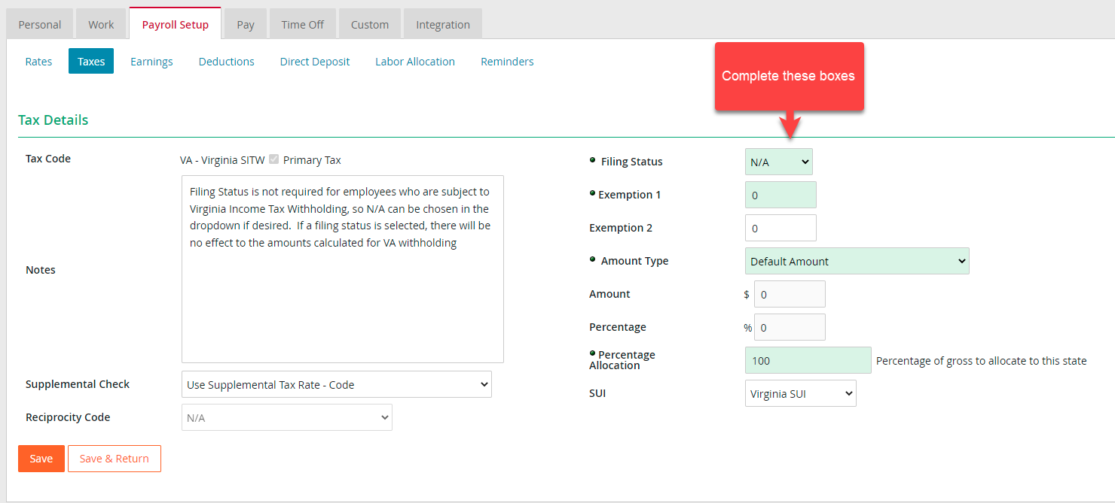

REMEMBER TO HIT SAVE. #done